# Fitness App User Documentation

## Table of Contents

1. Introduction

2. Installation

- iOS

- Android

3. Getting Started

- Creating an Account

- Logging In

4. App Features

Social Integration: Connect with like-minded individuals, share achievements, and provide support within a vibrant community.

Incentivized Rewards: Earn rewards for sticking to fitness goals, fostering motivation and accountability.

Personalized Guidance: Receive personalized guidance tailored to your fitness goals and BMI, ensuring a customized experience.

Support for Local Businesses: Partnered with local businesses to offer exclusive deals and discounts, supporting the community.

- 1. Home Screen

- 2. Nutritious Recipes

- 3. Calorie Intake Monitoring

- 4. BMI Tracking

- 6. Incentivized Rewards

- 7. Personalized Guidance

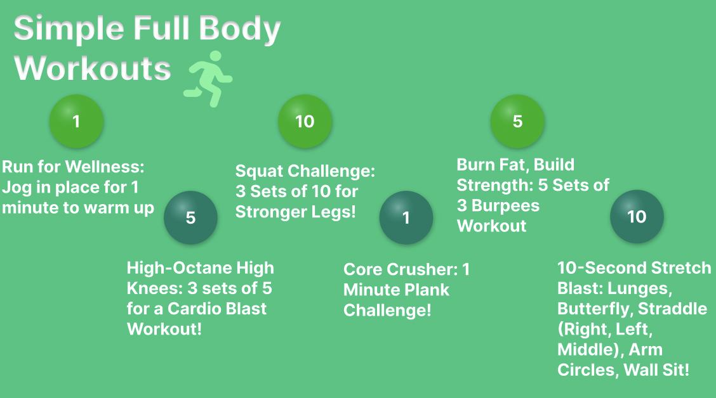

- 8. Support for Local Businesses

## 1. Introduction

Welcome to our fitness app! This user manual will guide you through the installation process, setting up your account, and using all the features our app has to offer.

## 2. Installation

### 2.1 iOS

1. Open the App Store on your iOS device.

2. Search for "Fitness App" in the search bar.

3. Tap on our app in the search results.

4. Tap "Get" to download and install the app.

5. Once installed, tap "Open" to launch the app.

### 2.2 Android

1. Open the Google Play Store on your Android device.

2. Search for "Fitness App" in the search bar.

3. Tap on our app in the search results.

4. Tap "Install" to download and install the app.

5. Once installed, tap "Open" to launch the app.

## 3. Getting Started

### 3.1 Creating an Account

1. Open the Fitness App on your device.

2. Tap on the "Sign Up" button to create a new account.

3. Enter your email address and create a password.

4. Fill in your personal information (name, age, gender, etc.).

5. Tap "Sign Up" to create your account.

![Creating an Account](https://example.com/account_creation_screenshot.png)

### 3.2 Logging In

1. Open the Fitness App on your device.

2. Enter your email address and password.

3. Tap "Log In" to access your account.

![Logging In](https://example.com/login_screenshot.png)

## 4. App Features

### 4.1 Home Screen

The home screen provides an overview of your fitness journey, including your current progress and upcoming goals.

![Home Screen](https://example.com/home_screen_screenshot.png)

### 4.2 Nutritious Recipes

Access a wide range of nutritious recipes to help you maintain a healthy diet.

1. Tap on the "Recipes" tab at the bottom of the screen.

2. Browse through the list of recipes or use the search bar to find specific recipes.

3. Tap on a recipe to view ingredients and cooking instructions.

![Nutritious Recipes](https://example.com/recipes_screenshot.png)

### 4.3 Calorie Intake Monitoring

Track your daily calorie intake to ensure you're meeting your nutritional goals.

1. Tap on the "Calorie Tracker" tab at the bottom of the screen.

2. Enter the foods you've eaten throughout the day.

3. The app will calculate your total calorie intake and display it on the screen.

![Calorie Intake Monitoring](https://example.com/calorie_tracker_screenshot.png)

### 4.4 BMI Tracking

Monitor your Body Mass Index (BMI) to track your progress over time.

1. Tap on the "BMI Tracker" tab at the bottom of the screen.

2. Enter your height and weight.

3. The app will calculate your BMI and display it on the screen.

![BMI Tracking](https://example.com/bmi_tracker_screenshot.png)

### 4.5 Social Integration

Connect with friends and family to share your progress and provide support to one another.

1. Tap on the "Social" tab at the bottom of the screen.

2. Follow other users and interact with their posts.

3. Share your own progress updates, photos, and achievements.

![Social Integration](https://example.com/social_integration_screenshot.png)

### 4.6 Incentivized Rewards

Earn rewards for reaching your fitness goals and staying active.

1. Tap on the "Rewards" tab at the bottom of the screen.

2. View available rewards and challenges.

3. Earn points for completing challenges and redeem them for prizes.

![Incentivized Rewards](https://example.com/rewards_screenshot.png)

### 4.7 Personalized Guidance

Receive personalized guidance and recommendations based on your fitness goals and progress.

1. Tap on the "Guidance" tab at the bottom of the screen.

2. Answer a few questions about your fitness goals and preferences.

3. Receive personalized recommendations for workouts, diet plans, and more.

![Personalized Guidance](https://example.com/guidance_screenshot.png)

### 4.8 Support for Local Businesses

Support local businesses by discovering fitness classes, gyms, and wellness services in your area.

1. Tap on the "Local Businesses" tab at the bottom of the screen.

2. Browse through the list of local businesses in your area.

3. View details about each business and book appointments directly through the app.

![Support for Local Businesses](https://example.com/local_businesses_screenshot.png)